University of Southern Indiana
CIS376 - Intermediate Web Development
Exercise 03

1. Modify Index.html by adding a link to “Assignment 3” - Exercise03.html, see example below.

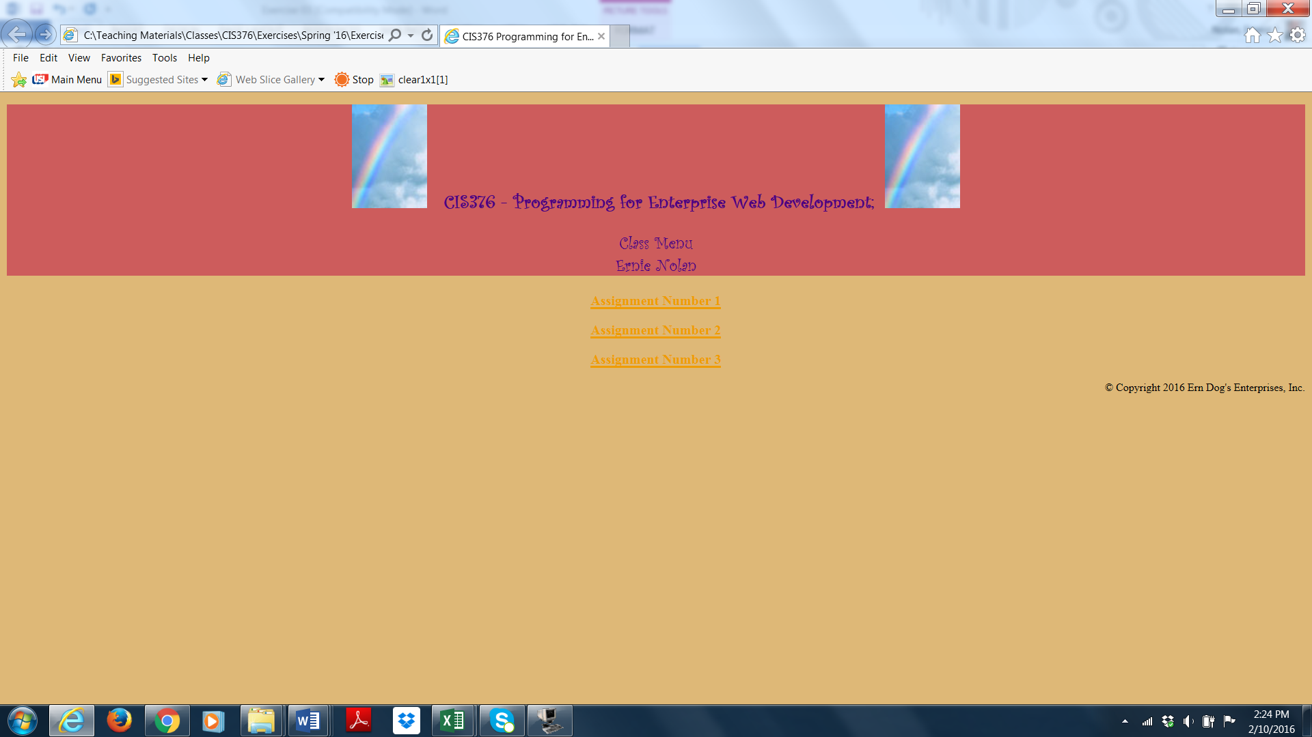
University of Southern Indiana
CIS376 - Intermediate Web Development
Exercise 03
Continued….

2. Create a page called Exercise03.html that looks similar to the example below but has your chosen style, look and feel.

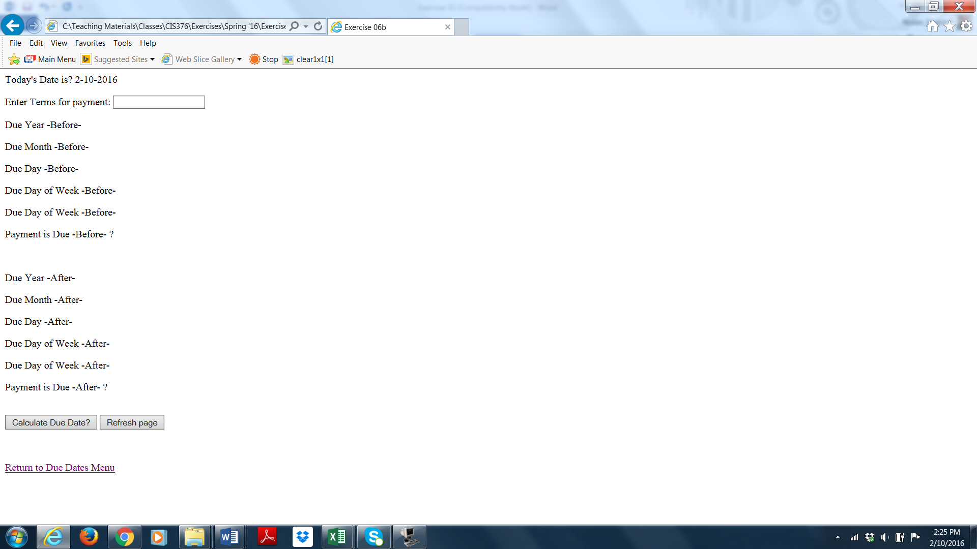
University of Southern Indiana
CIS376 - Intermediate Web Development
Exercise 03
Continued….

3 Exercise03.html should contain a form with an input field for Payment Terms along with a return link to Index.html.

4. The form should contain a “Submit” button linked “onclick” to a function written in JavaScript that will accept Input Terms, calculate due date and update the results in the Exercise03.html page.

If the day of the week is (Monday through Friday) the Due Date is todays date plus Payment Terms.
If the day of the week is (Saturday) then the Due Date is todays date plus Payment Terms minus 1.
If the day of the week is (Sunday) then the Due Date is todays date plus Payment Terms plus 1.

5. The source code for the JavaScript should be called DueDates.js and be placed in the Scripts folder.

6. Your javaScript should contain logic (Try Throw Catch) to validate the input and initiate an error message.

7. The form should also contain a “Refresh Page” button.

8. Your style sheets should always have the same name as the html page and be placed in the Styles folder.

9. Declare and use variables where appropriate.

20. Use document.getElementById("id tag name").innerHTML=variable as the vehicle for updating the HTML page from the JS page.

This assignment is due 09/30/16 at 11:30 PM and is worth 50 points.
